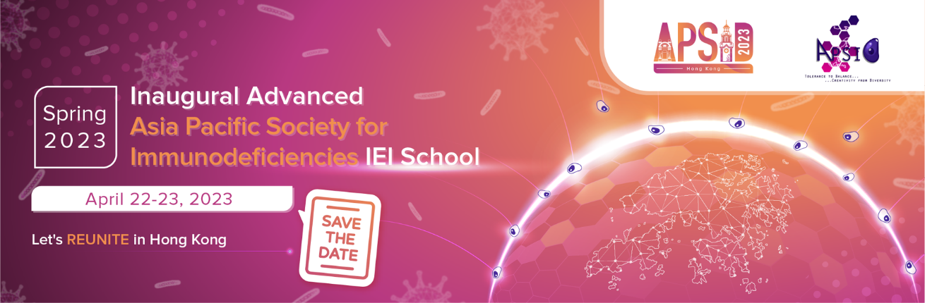

Let’s reunite in Hong Kong!

We are delighted to invite you to the Inaugural Advanced APSID IEI School Spring 2023, which will take place on April 22-23, 2023 in Hong Kong, China. Our website is now live at apsid2023.com.

A unique opportunity to meet in-person since the COVID-19 pandemic, please share your difficult cases and latest discoveries with students and faculty members across Asia, and contribute to the advancement of treatment, diagnosis and care of patients with immunodeficiencies. Submit your abstracts and increase the opportunity for collaboration by sharing your latest findings at APSID 2023. Airfare and accommodation of presenters will be sponsored.

APSID will solicit both clinical cases and research abstracts related to any topics in the general field of clinical and diagnostic immunology for the Inaugural Advanced IEI School. However, abstracts related to the topics of faculty lectures will be prioritised for oral presentation to enhance the coherence of the program.
- Autoinflammation
- Atopy
- CVID
- Viral and mycobacterial infections
- Bacterial infections
- Fungal infections
- Registry and national/regional cohort studies
- Screening
- Genomic testing and gene therapy
- Novel IEI genes
- Laboratory models of IEI, e.g. animal, organoid, iPSC
- HSCT
- COVID-19

Important dates:
16 January Abstract submission portal opens
31 January Abstract submission portal closes
6 February Abstract selection notification

The tentative agenda, faculty list, and abstract submission guidelines are available at apsid2023.com.Applicants shall register to be members of APSID or renew their memberships as soon as possible. Applicants from resource-limited countries (See footnote) may be eligible for a special award from the School, waiving their membership fee for 2 years.

Please click here for APSID Membership Registration

